St. Clare’s Abbey Nursery Unit Newsletter
September 2016

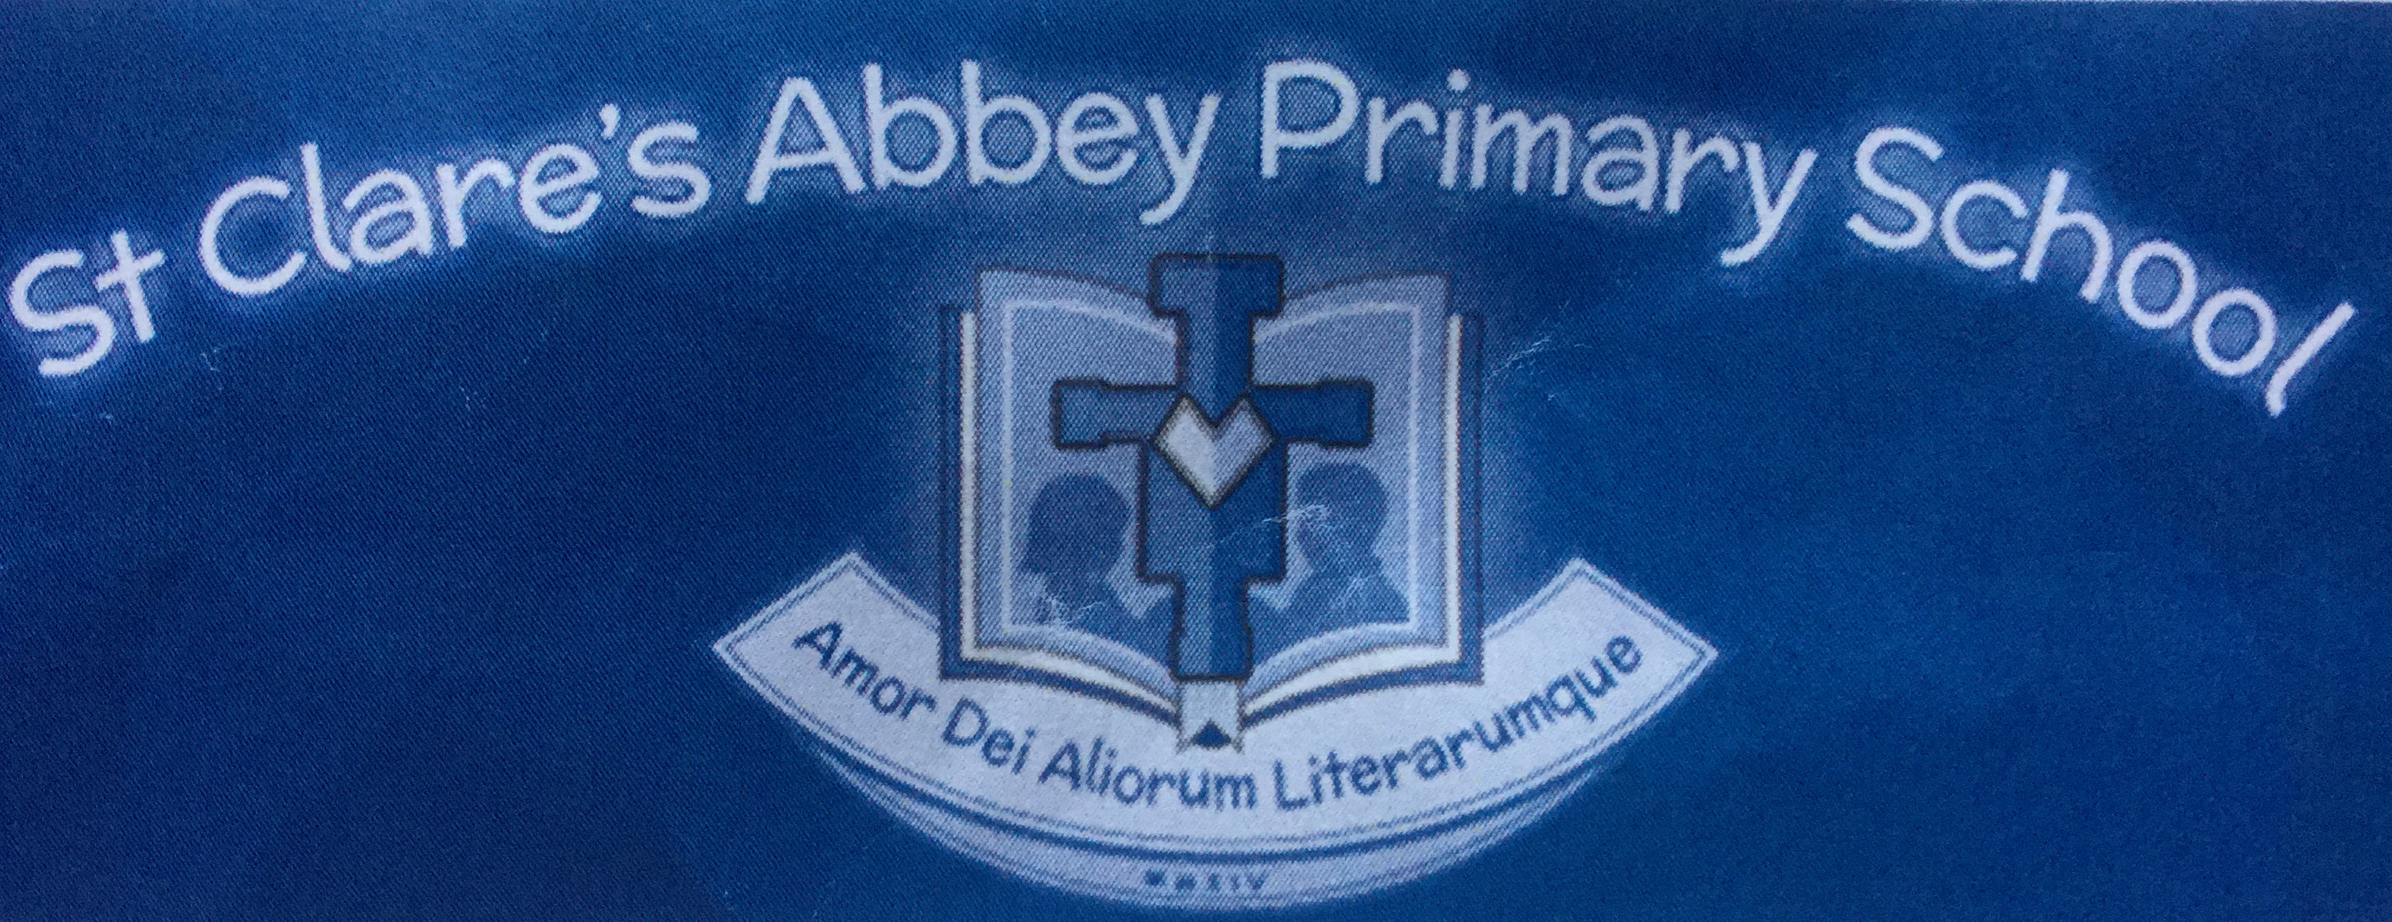

Welcome to the first newsletter of the new academic year. We are delighted to welcome you and your children into the Nursery. We are also thrilled to see some of our children from last year who have returned to the Nursery for another year. Please allow time for your child to adapt to the new surroundings and the new faces. We encourage you to stay with your child during these initial sessions until your child is absolutely at ease to remain in the Nursery without you. After our meetings in June I am sure that you took lots of information away with you and shared this with your child in preparation for Nursery. It is hoped that this transition will go smoothly when we all work together in the interests of your child.

As children are phasing in gradually during September, there will be lots of reinforcement and repetition of the monthly theme. We will focus on “Myself” and picking out colours, especially RED. In the “Myself” topic, we hope that children will be able to tell us their names and where they live. We will talk about family members, count how many people live in our houses and also name some parts of our bodies. This will all be done through play activities, art and singing.

Activities you can do with your child at home:

- Look at the number on your front door. Talk to your child about your address and see if they can remember it
- Name all the members of your immediate family and count them with your child.
- Use any opportunity for counting- walking up and down the stairs for example.
- Focus on picking out red objects – passing cars, apples in the fruit bowl. Play a game of finding red things
- Encourage independence at toileting and dressing

Your items from home

We would appreciate it if you could send in to school some RED non returnable items with your child. We will use these to enhance our play this month. These items may be natural or man-made.

We would also welcome old birthday cards throughout the year. These are ideal to practise our cutting and for helping children to recognise some numerals.

Photos

Hopefully by now you have all sent in the passport sized photos of your children and a family photo to school. If you still have not done this, we would appreciate it if you could do this as soon as possible.

Consent Forms

If you have not returned these to the Nursery please do so as soon as possible. E.g. toileting arrangements, photography, policies.

Questionnaire

We feel that Nursery and parents have worked so well in understanding the importance of this transition period and we are always interested in your opinions and views of our Nursery. You will soon have the opportunity to complete a questionnaire on how you found the settling in process. It will be available on the school website to be completed at home or in the Nursery cloakroom area. We encourage you to take a few minutes to share your feedback with us. You will be kept updated nearer the time.

Child’s Belongings

It is essential that any belongings you bring into school are labelled with the child’s name to ensure that items do not go missing. E.g. coat, bag, jumper.

Nut & other allergies

There are a number of children within the School who suffer from various, serious allergies and for this reason you are requested NOT to send foods of any kind into the Nursery. This includes celebration / Birthday cakes.
However, should you wish to send in a Birthday cake the only permitted one is Sainsbury’s Nut Free tray bake Birthday Cake in its unopened packaging.
We have been advised by the Allergy Nurse not to accept Horse Chestnuts / Conkers for the same reason.

September Birthdays

We wish the following children a very Happy Birthday this month:



Ben Murphy Laskowski 1st
Nikodem Kusa 12th

Jason Bradley 14th

Songs and rhymes

These are some of the songs and rhymes which we will be enjoying this month:

- See how high you can lift your hands
- Five red squirrels
- Tommy Thumb
- Head, shoulders, knees and toes
- Wind the bobbin up

See how high you can lift your hands

See how high you can lift your hands.
See how wide you can stretch your arms.
Now let’s see you touch your toes.
Put your finger on your nose.

Five red squirrels bushy and sweet (hold up fingers on one hand) 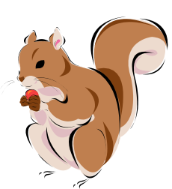
Five red squirrels bushy and sweet
Are looking for some nuts to keep (Hand in front of eyes looking all around)
One red squirrel climbs a tree (mime climbing)
Shuts his eyes and falls asleep (pretend to sleep)
So that leaves Four Red Squirrels

Tommy Thumb (hold up thumbs and appropriate fingers at “Here I am…”)


“Tommy Thumb, Tommy Thumb,
Where are you?”
“Here I am, here I am.
How do you do?”
Peter Pointer, Peter Pointer,
Where are you?”
“Here I am, here I am.
How do you do?”
Middle Man, Middle Man,
Where are you?”
“Here I am, here I am.
How do you do?”
Ruby Ring, Ruby Ring,
Where are you?”
“Here I am, here I am.
How do you do?”
Baby Small, Baby Small,
Where are you?”
“Here I am, here I am.
How do you do?”

Head, Shoulders, Knees and toes

Head, Shoulders, Knees and toes,
Knees and toes.
Head, Shoulders, Knees and toes,
Knees and toes.
Eyes and ears
And a mouth and nose.
Head, Shoulders, Knees and toes,
Knees and toes.

Wind the Bobbin up
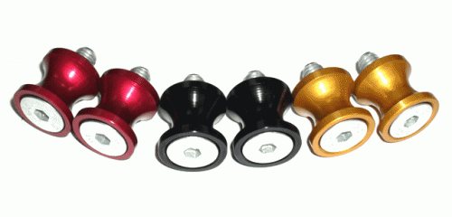
Wind the bobbin up,
Wind the bobbin up.
Pull, pull.
Clap, clap, clap.
Wind it back again,
Wind it back again.
Pull, pull.
Clap, clap, clap.
Point to the window,

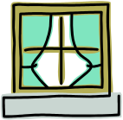

Point to the door.

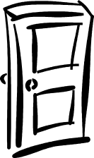

Point to the ceiling,

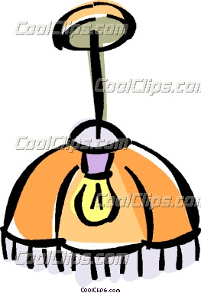

And point to the floor



Put your hands together,
One, two, three.
Place your hands upon your knee.



School closure

School will be closed for staff training on Monday 19th September for one day only.

