

E-Safety Policy
The best interests of our children must be a top priority in all our actions - Article 3

We are a school committed to promoting the rights of our children as per the UNICEF Rights Respecting Schools programme. Our work in this aspect of school life promotes the following articles:

Article 12: Every child has the right to say what they think in all matters affecting them, and to have their views taken seriously.

Article 16: Every child has the right to privacy. The law should protect the child’s private, family and home life.

Article 17: Every child has the right to reliable information from the mass media. Television, radio, newspapers and other media should provide information that children can understand. Governments must help protect children from materials that could harm them.

Article 19: Governments must do all they can to ensure that children are protected from all forms of violence, abuse, neglect and mistreatment by their parents or anyone else who looks after them.

Article 28: Every child has the right to an education. Primary education must be free.

Article 29: Education must develop every child’s personality, talents and abilities to the full. It must encourage the child’s respect for human rights, as well as respect for their parents, their own and other cultures and the environment.

Article 31: Every child has the right to relax, play and join in a wide range of cultural and artistic activities.
21st century life presents dangers including violence, racism and exploitation from which pupils need to be reasonably protected. At an appropriate age and maturity they will need to learn to recognise and avoid these risks — to become “Internet-wise” and ultimately good “digital citizens”.
DENI E-Safety Guidance, Circular number 2013/25

ICT
The term, Information and Communications Technology (ICT) covers a range of resources from traditional computer-based technologies to the fast evolving digital communication technologies.
Some of the Internet-based and electronic communications technologies which children are using, both inside and outside of the classroom, are:
- Websites
- Learning Platforms / Virtual Learning Environments
- Email and Instant Messaging
- Social Networking
- Blogs and Wikis
- Podcasting
- Video Broadcasting - Skype/Facetime
- Music Downloading
- Gaming
- Mobile/Smart phones with text, video and/or web functionality
- IPads and other tablet devices with internet access
While these ICT resources can be exciting and beneficial both in and out of the context of education, all users need to be aware of the range of risks associated with their use.

E Safety
This policy operates in conjunction with the following school pastoral policies:
- Policy for Promoting Positive Behaviour,
- Child Protection Policy and
- Anti Bullying Policy.

It has been written collaboratively with staff, parents and pupils. Some comments made by these stakeholder groups during consultation meetings were:
“My concern is that they will become part of a world that I know nothing about.”
(Parent Representative March 2015)
“I worry that I should be teaching my child, not him teaching me.”
(Parent Representative March 2015)

“I know that everything that is posted online is not true.”
(School Council Survey March 2015)
“I know that if someone is unkind to me online I can tell someone I trust.”
(School Council Survey March 2015)

This policy will be reviewed at the start of each school year as we know that the success of its implementation rests of the level of ‘buy in’ we have from our whole community.
Rationale
“All schools should have their own E-Safety Policy, which must operate in conjunction with other school policies including Behaviour, Child Protection, Anti-Bullying and Acceptable Use. E-Safety must be built into the delivery of the curriculum. ICT is a compulsory cross curricular element of the revised curriculum and schools must ensure acquisition and development by pupils of these skills”
DENI E-Safety Guidance, Circular number 2013/25
It is the responsibility of the schools, staff, governors and parents to mitigate risk through reasonable planning and actions. The requirement to ensure that children and young people are able to use the internet and related communications technologies appropriately and safely is addressed as part of the wider duty of care to which all who work in schools are bound. E-Safety covers not only internet technologies but also electronic communications via mobile phones, games consoles and wireless technology. We must demonstrate that it has provided the necessary safeguards to help ensure that it has done everything that could reasonably be expected to manage and reduce these risks. The E-Safety policy that follows explains how we intend to do this, while also addressing wider educational issues in order to help young people (and their parents / carers) to be responsible users and stay safe while using the internet and other communications technologies for educational, personal and recreational use.
What we understand by eSafety

- E-Safety concerns safeguarding children and young people in the digital world.

- E- Safety emphasises learning to understand and use new technologies in a positive way.

- E-Safety is less about restriction and more on education about the risks as well as the benefits so pupils can feel confident online.

- E-Safety is concerned with supporting children and young people to develop safer online behaviours both in and out of school.

- E-Safety is concerned with helping pupils recognise unsafe situations and how to respond to risks appropriately.

In St Clare’s Abbey P.S. we understand our responsibility to educate pupils in e-Safety. We aim to teach children appropriate behaviours and critical thinking to enable them to remain both safe and legal when using the internet and related technologies, in and beyond the context of the classroom.
Scope of the Policy
This policy applies to all members of the School community who have access to and are users of the school ICT systems, both in and out of the School. In relation to incidents that occur during school hours, we will work with parents, staff and pupils to ensure E-Safety of all involved, apply sanctions as appropriate and review procedures.
In relation to E-Safety incidents that occur outside of school hours, the School will work with pupils and parents to keep all pupils safe and offer educative support where appropriate. E-Safety outside school hours is primarily the responsibility of the parents. If inappropriate activity occurs outside school hours with the intention of having a negative effect on any member of the School community, and this is brought to our attention, then we will liaise with parents as to an appropriate way forward. Any issues that arise inside school, as a result of E-Safety incidents outside of the School, will be dealt with in accordance with School Policies.
Risks and Responses

The Internet is an exciting resource. It brings the world into the classroom by giving children access to a global network of educational resources. There is no doubt that the use of the Internet is an essential skill for children as they grow up in the modern world. The Internet is, however, an open communications’ channel, available to all. Anyone can send messages, discuss ideas and publish materials with little restriction. This brings young people into contact with people from all sectors of society and with a wide variety of materials some of which could be unsuitable.

Pupils will be informed that network and Internet use will be monitored.

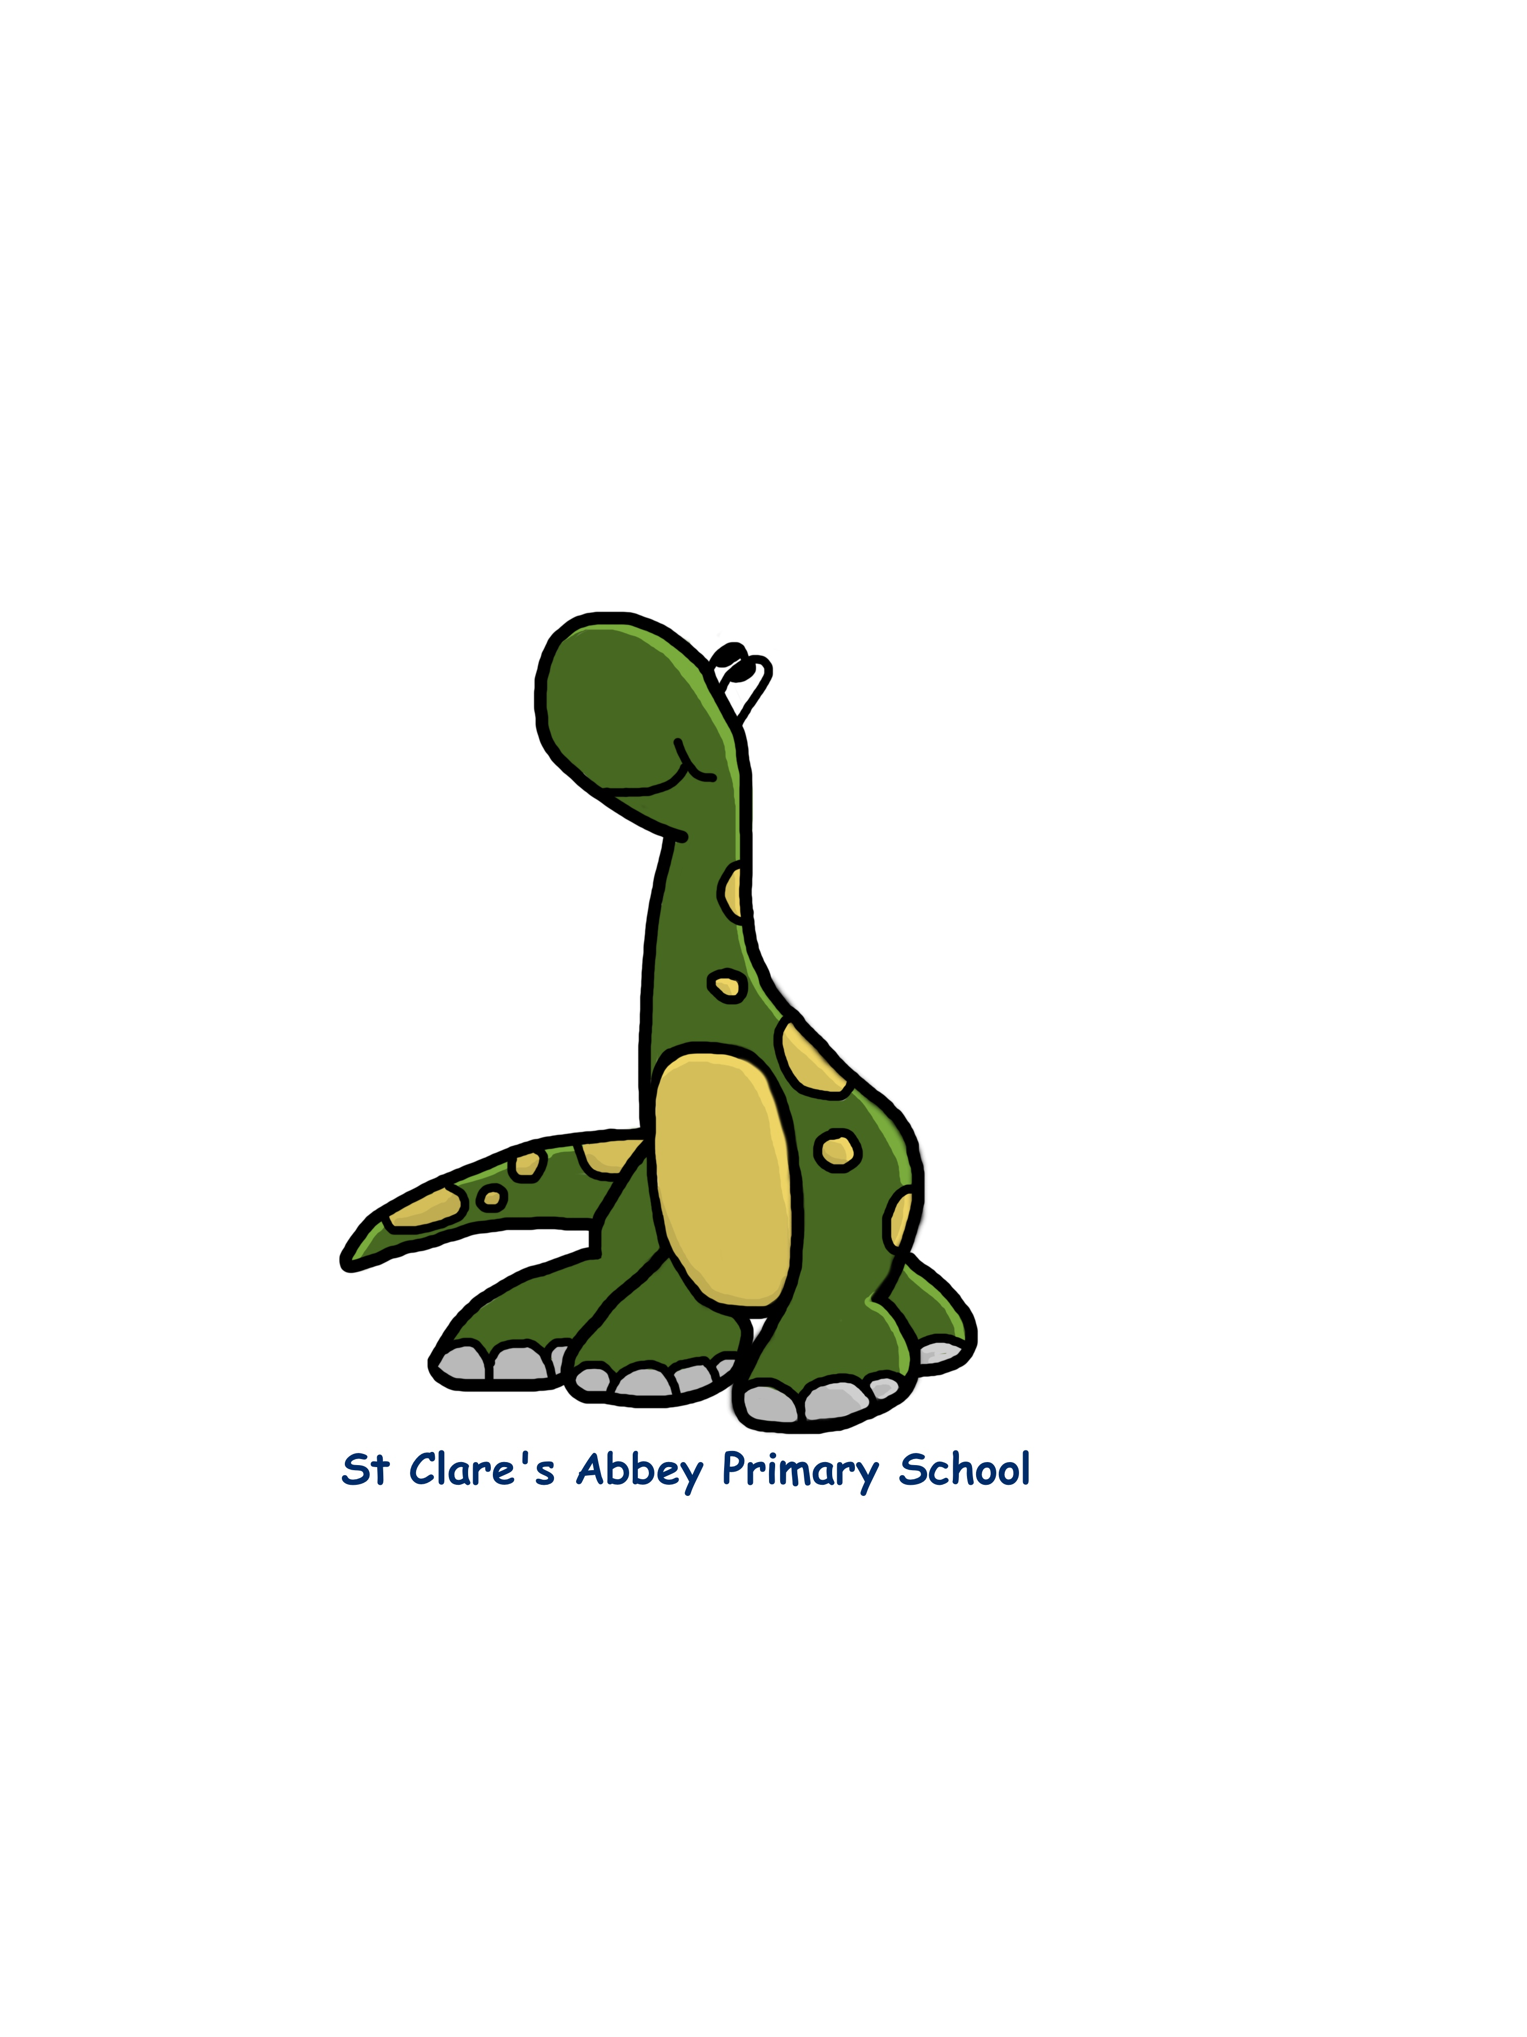
We have identified 4 Key areas of risk (Contact, Content, Conduct and Commercial) and have highlighted the steps that we will take to educate and equip our pupils with the skills and knowledge required to minimise the risk and address it should it arise. In St Clare’s Abbey our Digital Mascot ‘Techno’ has been created to make our pupils aware of these risks and how to keep themselves safe online.

Risk 1: Potential Contact with Strangers
Techno says, “Never talk to strangers online or give them your details.”
Children may come into contact with someone on-line who may wish to harm them. Some adults use social networks, chat rooms or e-mail to communicate with children for inappropriate reasons, e.g. grooming.
Personal Information can be accessed leading to unauthorised access to / loss of / sharing of personal information.
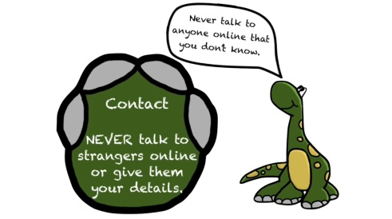
To address this risk within St Clare’s Abbey our children will be taught:

- That people are not always who they say they are.
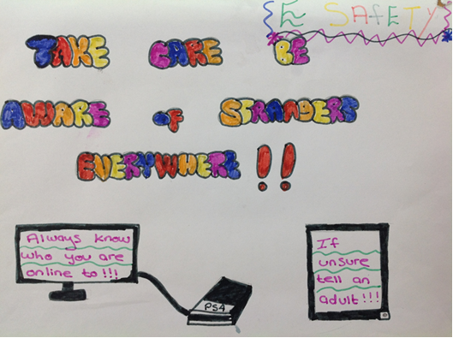
- That “Stranger Danger” applies to the people they encounter through the Internet.
- That they should never give out personal details.
- That they should never meet alone anyone contacted via the Internet, and
- That once they publish information (e.g. send inappropriate photographs) it can be disseminated with ease and cannot be destroyed.

Cyber-bullying. We are very aware of the potential for pupils to be subjected to cyber bullying via e.g. email, text or social networking sites.

Having surveyed the School Council (March 2015) we discovered that a small number of children had been subjected to cyber bullying outside of school. CEOP data states that 21% of 8 – 11 year olds have been deliberately targeted, threatened or humiliated by an individual or group through the use of mobile phone or the internet (Beatbullying, Virtual Violence ll).

If it takes place, cyber-bullying will be dealt with in line with the school’s Anti-bullying Policy, Policy for Promoting Positive Behaviour and other Pastoral Procedures and Practices.

To reduce this risk, within St Clare’s Abbey pupils will be taught:

- That if they feel they are being bullied by e-mail, through social networking sites, text or online and that they cannot get it to stop through their own efforts that they should always tell someone they trust.
- Not to reply to bullying, threatening text messages or e-mails as this could make things worse.
- Not to send or forward abusive texts or e-mails or images to anyone.
- That whilst they may be able to appear anonymous most messages can be traced back to their creator and cyber bullying can constitute a criminal offence.
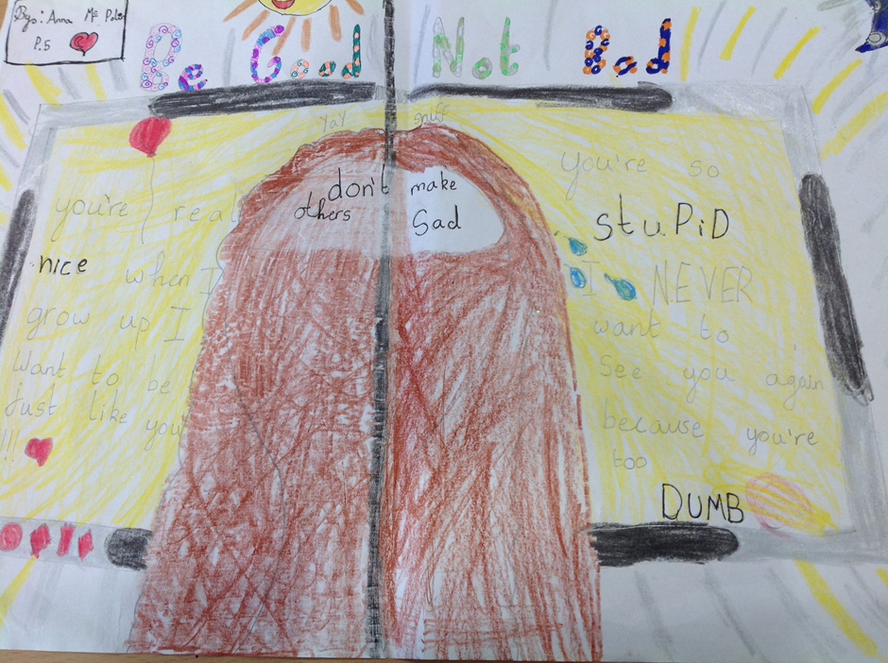
- Keep abusive messages as evidence.
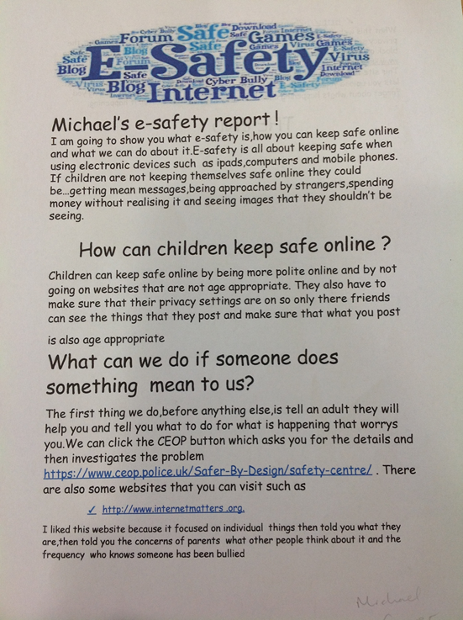
Children will be encouraged to report incidents of cyber-bullying to parents and the school to ensure appropriate action is taken.

Children will be encouraged to use websites such as www.thinkuknow.co.uk to learn how to deal with cyberbullying incidents which may take place in or outside of school

We will keep records of cyber-bullying incidents, if they have occurred within school, to monitor the effectiveness of preventative activities, and to review and ensure consistency in investigations; support and sanctions (see Anti Bullying Policy)

Risk 2: Accessing Inappropriate Content
Techno says, “If unsure always tell and show an adult”.

“I know that everything that is posted online is not true.”
(School Council Survey 2015)

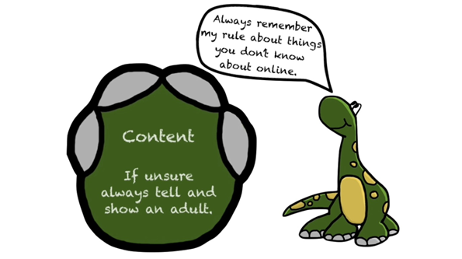
Through the Internet there are unsuitable materials in many varieties. Anyone can post material on the Internet. Some material is published for an adult audience and is unsuitable for children e.g. materials with a sexual content. Children can access illegal, harmful or inappropriate images or other content.
Materials may express extreme views e.g. some use the web to publish information on weapons, crime and racism which would be restricted elsewhere.
There is access to unsuitable video / internet games.
There is an inability to evaluate the quality, accuracy and relevance of information on the Internet. Materials may contain misleading and inaccurate information e.g. some use the web to promote activities which are harmful such as anorexia or bulimia.

To address this risk within St Clare’s Abbey our children will be taught:

- That information on the Internet is not always accurate or true.
- To question the source of information.
- How to respond to unsuitable materials or requests and that they should tell a teacher/adult immediately.
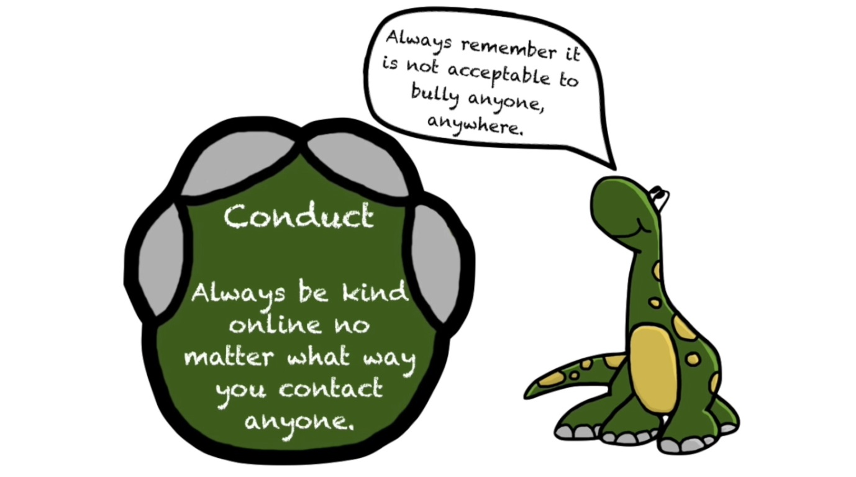
Risk 3: Online Behaviour and Conduct
Techno says, “Always be kind online no matter what way you contact anyone.”
- There is potential for excessive use of technologies, and the internet, which may impact on social and emotional development and learning of our pupils (too much screen time).
- It is tempting for pupils to ‘Copy and paste’ information from the internet without referencing it or fully understanding what they are reading.
- There is the possibility that children could illegally download music, videos and games.
- Unintentional sharing and distribution of personal images without an individual’s consent or knowledge.
- The potential for ‘negative’ online behaviours to impact on future opportunities.

To address this risk in St Clare’s Abbey children will be taught:
- Excessive hours spent on the Internet/gaming is not healthy.
- Pupils will be taught in all relevant lessons to be critically aware of the materials / content they access online and be guided to validate the accuracy of information and to respect Copyright when using material accessed on the Internet.
- The dangers and possible repercussions of downloading illegally.
- It is illegal to take pictures of anyone without them knowing.
- Nothing they send, write or do on the internet can ever be erased completely.
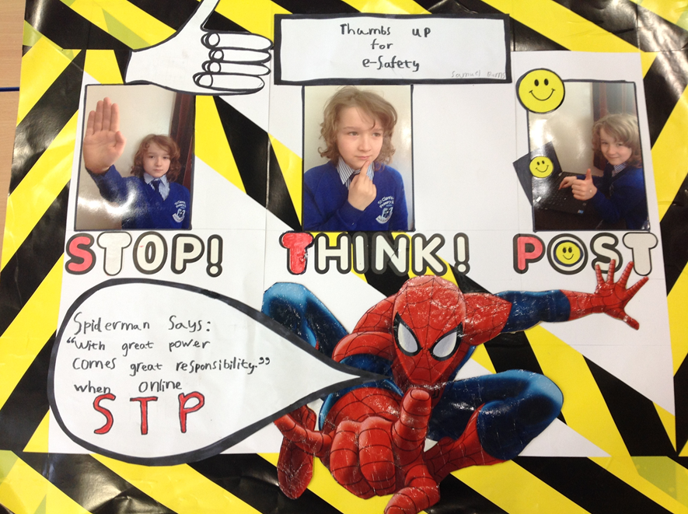
As with all other risks, it is impossible to eliminate those risks completely. It is therefore essential through good educational provision to build children’s resilience to the risks to which they may be exposed, so that they have the confidence and skills to deal with these risks.


Risk 4: Commercial
Techno says, “Never open any pop-up windows or marketing emails. Always tell an adult.”
When using the internet children may encounter commercial advertising pop-ups or be asked to click on links that may be harmful to them or the computer.
To address this risk within St Clare’s Abbey our children will be taught:
- Adverts on the internet should always be questioned.
- Not to click on or open any pop-ups.
- Always tell an adult.
Whilst no scheme of work is in place for the teaching of ESafety, we address it constantly through:
- Technosaur ‘Techno’ (Launched 20th January 2017). Techno has four eSafety rules (Digital Paw Print). These correspond to the four risks outlined above. Techno’s rules will be built on as pupils progress from P1 – P4 and reinforced and extended from P5 – P7. P1 – Content, P2 – Conduct, P3 – Contact, P4 – Commercial.
- Providing opportunities across the curriculum for children to develop their e-Safety skills.
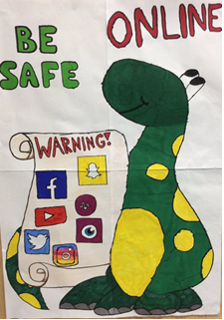
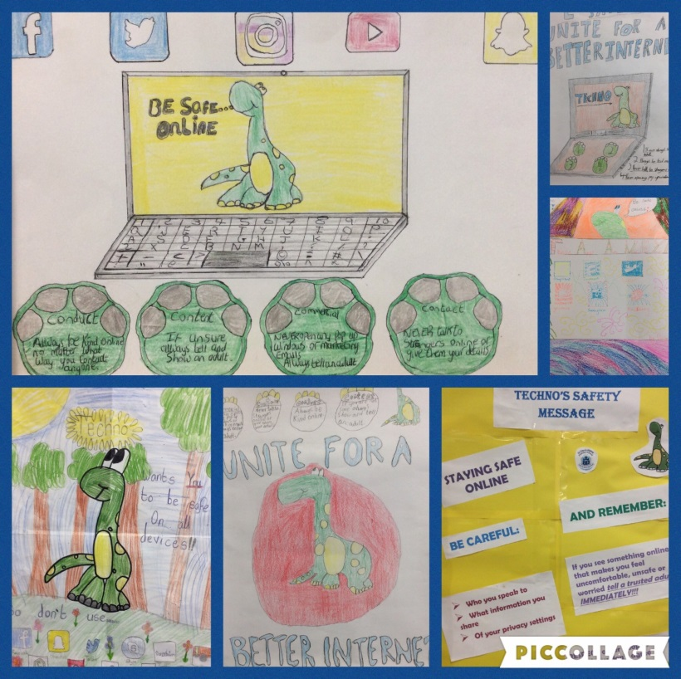
- Educating children on the dangers of technologies that may be encountered outside school when opportunities arise (either at designated times or as incidental contexts arise).
Roles and Responsibilities

As e-Safety is an important aspect of strategic leadership within the school, the Principal and Board of Governors have ultimate responsibility to ensure that the policy and practices are embedded and monitored. It is the role of the ICT Co-ordinators to keep abreast of current e-safety issues and guidance through organisations such as CEOP (Child Exploitation and Online Protection) and Childnet.
Miss Rocks and Mrs McParland have responsibility for leading and monitoring the implementation of e-safety throughout the school. The ICT co-ordinators will work closely with the Designated teacher for Child Protection (Mrs Toner) and Deputy Designated teachers for Child Protection (Mr Sweeney, Miss O’Shea, Mrs Doherty, Mrs Bennett & Mrs Donnelly) to promote e-safety and address any concerns that may arise in this area.
The Principal/ICT Co-ordinators update Senior Management and Governors with regard to e-safety and all governors have an understanding of the issues at our school in relation to local and national guidelines and advice.
The ICT Co-ordinators will lead E-Safety within the school and take day to day responsibility for E-Safety issues and have a leading role in establishing and reviewing the Schools policies/documents.
The ICT Coordinators will:
• Ensure that all staff are aware of the procedures that need to be followed in the event of an E-Safety incident taking place.
• Provide training and advice for staff
• Liaise with C2K, iTeach and school ICT technical staff
• Liaise with the EA and DENI on E-Safety developments
• Work with Mr Sweeney (Safeguarding Team) to receive reports of E-Safety incidents and create a log of incidents to inform future ESafety developments.
• Meet with Mrs Monaghan, Mr Sweeney and Safeguarding Team to investigate abuse of social network sites by pupils if necessary
• attend relevant meetings with Board of Governors
• discuss current issues, review incident logs
• Monitor and report to senior staff any risks to staff of which the E-Safety coordinator is aware
• Oversee the application of the 360 Degree Safe Mark Award (plan for 2016/17).
Writing and Reviewing the e-Safety Policy
This policy, supported by the school’s ‘Acceptable Use Agreements’ for staff, governors, visitors and pupils and the Staff Code of Conduct is to protect the interests and safety of the whole school community. It is linked to other school policies including those for:
- ICT
- Policy for Promoting Positive Behaviour
- Health and Safety
- Child Protection
- Anti-bullying.
It has been agreed by the Senior Management Team, Staff, parents and pupils and has been ratified and adopted by the Board of Governors. The e-Safety Policy and its implementation will be reviewed annually.
Role of Governors
Governors are responsible for the approval of the E-Safety Policy and for reviewing the effectiveness of the policy. This will be carried out by the Governors receiving regular information about E-Safety incidents and monitoring reports.
Mr Shane Comer has taken on the role of E-Safety Governor.
He will:
• have meetings with the E-Safety Coordinators and Online Safety Group
• monitor e-safety incidents logs

Training will be given to the Governors by:
• Attendance at training provided by relevant external agencies / staff in school
• Participation in school’s training / information sessions for staff or parents
Safeguarding Team
The Safeguarding team are aware of the potential for serious child protection issues to arise from:
- Sharing of personal data
- Access to illegal/inappropriate materials
- Inappropriate online contact with adults/strangers
- Potential or actual incidents of grooming
- Cyber-bullying
The member of the Safeguarding team responsible for reporting ESafety concerns to is Mr Sweeney.
The Network Managers
- The school Internet access is filtered through the C2k managed service using a Websense filtering solution and via the Classnet system facilitated and monitored by school and ITeach. This system was risk assessed and approved by Governors for installation. The safeguarding reassurances and key guidance documents provided by ITeach personnel are attached to the policy for reference.
- Websense assesses all websites based on their content and adds them to a category. (Green – available, Red – unavailable) All users are given access to a core group of green sites. The school has the facility to customise security options where need arises. Access to the most inappropriate sites, including those on the Internet Watch Foundation banned list will always remain blocked.
Miss Rocks and Mrs McParland, will monitor that C2K e-safety measures, as recommended by DENI, are working efficiently within the school.
• That C2k/Classnet operates with robust filtering and security software.
• That monitoring reports of the use of C2k / Classnet are available on request.
• That the school infrastructure and individual workstations are protected by up to date virus software.
• That the school meets required e-safety technical requirements that users may only access the networks and devices through a properly enforced password protection policy. Passwords are regularly changed, the filtering policy is applied and that its implementation is not the sole responsibility of any single person that they keep up to date with E-Safety technical information in order to effectively carry out their e-safety role and to inform and update others as relevant.
• That the “administrator” passwords for the school ICT system, used by the Network Managers must also be available to the Principal and kept in a secure place.

The Role of the Staff
Teachers are the first line of defence in e-Safety; their observation of behaviour is essential in recognising concerns about pupils and in developing trust so that issues are reported. Incidents will vary from the prank or unacceptable behaviour to illegal activity.
- All staff have an up-to-date awareness of e-safety matters and of the current school ESafety policy and practices.
- No filtering service is 100% effective; therefore all children’s use of the Internet is supervised by an adult.
- Use of the Internet is a planned activity. Aimless surfing is not encouraged. Children are taught to use the Internet in response to a need e.g. a question which has arisen from work in class.
- Children are taught what Internet use is acceptable and what is not and given clear objectives for Internet use.
- Children are educated in the effective use of the Internet in research, including the skills of knowledge location, retrieval and evaluation.
- The school will ensure that the use of Internet derived materials by staff and pupils complies with copyright law.
- Children are taught to be Internet Wise. In St Clare’s Abbey our Digital Mascot ‘Techno’ has been created to make our pupils aware of these risks and how to keep themselves safe online. They will be taught Techno’s 4 rules of online safety.

Contact
Never talk to strangers online or give them your details.
Content
If unsure always tell and show an adult.
Conduct
Always be kind online no matter what way you contact
anyone.
Commercial
Never open any pop-up windows or marketing emails.
Always tell an adult.

E-Safety implications for online conduct for Staff
- Staff will be aware that Internet use can be monitored and traced to the individual. Professional conduct is essential.
- A laptop/iPad issued to a member of staff remains the property of the school. Users of such equipment should therefore adhere to school policy regarding appropriate use with regard to Internet access, data protection and use of software, both in and out of school.
- They have read, understood and signed the school’s Staff Acceptable Use Policy.
- All staff have been made aware of individual responsibilities relating to the safeguarding of children within the context of e-Safety and know to report an incident of concern to the school Designated Teacher for Child Protection/Safeguarding Team and/or the teachers responsible for e-Safety.
- New staff members receive information on the school’s e-Safety Policy and Acceptable Use Agreement as part of their induction.
- All teachers are encouraged to ensure E-Safety issues are embedded in all aspects of the curriculum and other school activities.
- St Clare’s Abbey staff review each year as part of this policy’s review the level of internet filtering allocated to each group of users.
- Staff are asked not use home email accounts for school business. Digital communications with students (email / Virtual Learning Environment (VLE) should be on a professional level only carried out using official school systems – either C2K or School Gmail accounts. Emails should be sent in accordance with the School’s guidance.
- School staff will not add children as ‘friends’ if they use social networking sites. They will not correspond with parents or relatives of pupils about school business via social networking sites. Staff will not discuss school business via these sites.
- Staff will ensure that pupils have a good understanding of research skills and need to avoid plagiarism and uphold The Copyright, Designs and Patents Act 1998(KS2).
- Staff monitor ICT activity in lessons, extracurricular and extended school activities.
- Staff are aware of e-safety issues related to the use of mobile phones, camera and hand-held devices and that they monitor their use and implement current school policies with regard to these devices.
- Staff will undertake all e-safety training as organised by the school.
NB Please refer to the ‘Staff Code of Conduct’ policy, written and adopted in Term 1 of 2014/15 school year - opening year of St Clare’s Abbey.

E-Safety Information for Parents/Carers
“My concern is that they will become part of a world I know nothing about.”
(Parent Representative March 2015)
Parents/carers have an important role to play in promoting e-Safety. We encourage all parents/carers to become involved in e-Safety discussions and activities with their child.

- The school website contains a page dedicated to E-Safety with links to sites such as CEOP’s thinkuknow, Childline, and the Kidsmart page which parents can use with their children. The school app and Twitter account will be used for notifications.
- The school communicates relevant e-Safety information through parents’ evenings/newsletters, the school website/app and Twitter account.
- Parents/carers are asked to read through and sign the Acceptable Use Agreement with their child.
- Parents/carers are required to give written consent to images of their child being taken/used on the school website.

“I worry that I should be teaching my child, not him teaching me.”
(Parent Representative March 2015)

Parents are reminded regularly that it is important to promote e-Safety in the home and to monitor Internet use. The following guidelines are provided:

- Keep the computer in a communal area of the home.

- Be aware that children have access to the internet via gaming stations and portable technologies such as smart phones.

- Monitor on-line time and be aware of excessive hours spent on the Internet.

- Take an interest in what children are doing. Discuss with the children what they are seeing and using on the Internet.

- Advise children to take care and to use the Internet in a sensible and responsible manner. Know Techno’s rules and the SMART tips and promote them at home.

- Discuss the fact that there are websites/social networking activities which are unsuitable.

- Discuss how children should respond to unsuitable materials or requests.

- Remind children never to give out personal information online.

- Remind children that people on line may not be who they say they are.

- Be vigilant. Ensure that children do not arrange to meet someone they meet on line.

- Be aware that children may be using the Internet in places other than in their own home or at school and that this internet use may not be filtered or supervised.

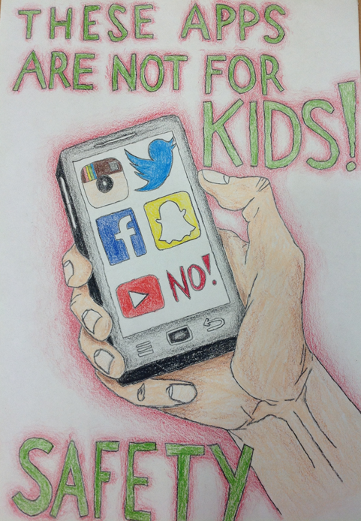

ESafety implications re specific aspects of ICT
Password Security

- Adult users are provided with an individual login username and password, which they are encouraged to change periodically. Login details should not be shared with pupils.
- All pupils are provided with an individual login username and password. They are encouraged to keep details of usernames and passwords private.
- Pupils are not allowed to deliberately access files on the school network which belong to their peers, teachers or others.
- Staff are aware of their individual responsibilities to protect the security and confidentiality of the school network, MIS systems.

E-mail:
- Pupils may only use C2k e-mail/school provided Gmail accounts on the school system (Report Bullying on My School – launch in Nov 2016/2017).
- Pupils must immediately tell a teacher if they receive offensive e-mail.
- Pupils must not reveal personal details of themselves or others in e-mail communication, or arrange to meet anyone without specific permission.
- Forwarding chain letters is forbidden.
- Sending or displaying insulting or offensive messages/pictures is forbidden.
- Using obscene language is forbidden.

Social Networking:
- Through the C2k system our school currently blocks access to social networking sites.
- Pupils and parents will be advised that the use of social network spaces outside school is inappropriate for primary aged pupils. However, we accept that some pupils will still use them; they will be advised never to give out personal details of any kind, which may identify them or their location.
- Pupils are advised to set and maintain profiles on such sites to maximum privacy and deny access to unknown individuals.
- Our pupils are asked to report any incidents of bullying to the school.
- Staff will not add children as ‘Friends’ on social networking sites.
- Photographs of children not available on 3rd Party Websites without permission and never for third party Facebook pages

Portable Technologies
- The use of portable devices such as memory sticks and external hard drives will be monitored closely as potential sources of computer virus and inappropriate material.
- Staff should not store pupils’ personal data and photographs on memory sticks.

Mobile Phones
- Pupils are not allowed to bring personal mobile phones to school unless required to do so by class teacher as part of their learning e.g. to be used with Google Cardboard, to be used for Leavers’ Celebration.
- Staff should not use personal mobile phones during working hours. If there is a need to be contactable please inform Mr Sweeney or Mrs Monaghan and this can be accommodated.
Given the vastness of our building and its grounds the following exceptions will be made:
All teachers are asked to keep their phone on when outdoors to facilitate contact with school office.
The First Aides are asked to keep their phones switched on in the event of an emergency.
The school caretakers are also asked to keep their phones switched on.
- Staff are advised not to use their own personal phones or devices for contacting pupils and their families within or outside of the setting in a professional capacity unless number is blocked. Staff will have the use of a school phone where contact with pupils or parents is required.

iPads

iPads are used for digital storytelling, internet research, and to support learning and teaching across the curriculum via the use of a range of appropriate apps. When using iPads, children will be reminded to be Internet Wise and apply the Internet safety rules. They will not be allowed to use iPads to:
- Take photos of pupils/staff without permission or direction from the teacher.
- Take videos of pupils/staff without permission or direction from the teacher.

Managing Video-conferencing
- Videoconferencing will be via the C2k network/Classnet to ensure quality of service and security.
- Videoconferencing will be appropriately supervised.

Digital Recordings
- We use specialist lesson recording equipment on occasions as a tool to share best teaching practice and celebrate pupil achievement. We do not reveal any such recordings outside of the staff and will not use for any other purposes.

CCTV
- We have CCTV in the school as part of our site surveillance for staff and student safety. We will not reveal any recordings without permission, except where disclosed to the Police as part of a criminal investigation.

Publishing Pupils’ Images and Work
- Written permission from parents or carers will be obtained before photographs of pupils are published on the school and third party websites. This consent form is considered valid for the entire school year unless there is a change in the child’s circumstances where consent could be an issue.
- Parents/carers may withdraw permission, in writing, at any time.
- Photographs that include pupils will be selected carefully and will not enable individual pupils to be clearly identified.
- Pupils’ full names will not be used anywhere on the School Website, particularly in association with photographs.
- Pupil’s work can only be published by outside agencies with the permission of the pupil and parents. A signed consent form will be requested at the start of the year.
- Photographs of children not available on 3rd Party Facebook Pages.
Authorising Internet Access
- Pupil instruction in responsible and safe use should precede any Internet access and all children must sign up to the Acceptable Use Agreement for pupils and abide by the school’s e-Safety rules. These e-Safety rules will also be displayed clearly in all rooms.
- All parents/guardians will be asked annually to sign the Acceptable Use Agreement for pupils giving consent for their child to use the Internet in school by following the school’s e-Safety rules and within the constraints detailed in the school’s e-Safety policy.
- All staff must read and agree in writing to adhere to the Acceptable Use Agreement for Staff before using any school ICT resource.

Handling e-Safety Complaints

- Complaints of Internet misuse will be dealt with by a senior member of staff.
- Deliberate access to inappropriate materials by any user will lead to the incident being logged by the ICT Co-ordinator and recorded in the e-Safety incident logbook (kept in the main office).
- As part of the Acceptable Use Agreement children will know that if they deliberately break the rules they could be stopped from using the Internet/E-mail and that parents/carers will be informed.
- Complaints of a child protection nature will be dealt with in accordance with school child protection procedures.
- Complaints regarding cyberbullying will be dealt with in line with the school Anti-Bullying Policy.
- Pupils and parents will be informed of the complaints’ procedure.
- Any complaint about staff misuse must be referred to the Principal and governors.

Communicating the Policy:
With pupils:
- e-Safety rules will be displayed in all classrooms and the ICT suite and discussed with the pupils at the start of each year. Specific lessons will be taught by class teachers at the beginning of every year and at relevant points throughout e.g. during PDMU lessons/circle times/anti-bullying week.

Staff:
- All staff will be involved in discussions regarding e-Safety and will have access to a copy of the e-Safety Policy.

Parents:
- A parents’ working group inputted into this policy.
- The policy is displayed on the website and all parents are notified of this.
- At the start of each year parents receive a copy of the Code of Conduct and are asked to sign the Acceptable Use Agreement on behalf of their child.

Monitoring and review

This policy is implemented on a day-to-day basis by all school staff and is monitored by the ICT Co-ordinators.

This policy is the governors’ responsibility and they will review its effectiveness annually. They will do this through liaison with the ICT Co-ordinators and a representative of the Safeguarding Team.
We sought guidance from iTeach in compiling this policy and will continue to involve them in monitoring the effectiveness of our E Safety procedures.

Dear Parent/ Carer

ICT including the internet, e-mail and mobile technologies has become an important part of learning in our school. We expect all children to be safe and responsible when using any ICT.
In St Clare’s Abbey our Digital Mascot ‘Techno’ has been created to make our pupils aware of online risks and how to keep themselves safe. Please read and discuss these eSafety rules with your child and return the slip at the bottom of this page. If you have any concerns or would like some explanation please contact Mrs Monaghan.

Please take care to ensure that appropriate systems are in place at home to protect and support your child/ren.



Parent/ carer signature
We have discussed this document with ……………………………………………(child’s name) and we agree to follow the eSafety rules and to support the safe use of ICT at St Clare’s Abbey Primary School.
Parent/ Carer Signature …….………………….………………………….
Class …………………………………. Date ………………………………

Primary Pupil Acceptable Use
Agreement / eSafety Rules

- I will only use ICT in school for school purposes.

- I will not tell other people my ICT passwords.

- I will only open/delete my own files.

- I will make sure that all ICT contact with other children and adults is responsible, polite and sensible as per Techno’s rules.

- I will not deliberately look for, save or send anything that could be unpleasant or nasty. If I accidentally find anything like this I will tell my teacher immediately as per Techno’s rules.

- I will not give out my own/others details such as name, phone number or home address as per Techno’s rules. I will not arrange to meet someone or send my image unless this is part of a school project approved by my teacher and a responsible adult comes with me.

- I will be responsible for my behaviour when using ICT because I know that these rules are to keep me safe.

- I will support the school approach to online safety and not deliberately upload or add any images, video, sounds or text that could upset any member of the school community.

- I know that my use of ICT can be checked and my parent/carer contacted if a member of school staff is concerned about my safety.

- I will not sign up for any online service unless this is an agreed part of a school project approved by my teacher.

- I will only open e-mail attachments from people I know, or who my teacher has approved

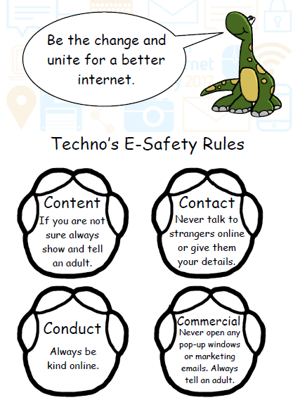

Follow these SMART TIPS to Stay Safe Online

S
Secret - Always keep your name, address, mobile phone number and password private – it’s like
giving out the keys to your home!

M
Meeting someone you have contacted in cyberspace can be dangerous. Only do so with your parent’s/carer’s permission, and then when they can be present.

A
Accepting e-mails or opening files from people you don’t really know or trust can get you into trouble – they may contain viruses or nasty messages.

R
Remember someone on-line may be lying and not be who they say they are. Stick to the public areas in chat rooms and if you feel uncomfortable simply get out of there!

Tell your parent or carer if someone or something makes you feel uncomfortable or worried.
T

SMART Tips from: – Helping your parents be cool about the Internet. Produced by: Northern Area Child Protection Committee.

Code of Practice

For Primary Parents regarding eSafety rules
- I will give written confirmation to the school to allow my child(ren) access to the Internet through a filtered service.
- I will keep computer/laptop/tablet devices in a communal area of the home.
- I will monitor online time and be aware of excessive hours spent on the Internet/gaming.
- I will take an interest in what the children are doing. I will discuss with the children what they are seeing and using on the Internet/gaming.
- I will remind them that their online reputation can last a lifetime and so they should always be responsible, polite and sensible whilst online.
- I will read Techno’s Rules and the SMART tips, and discuss these regularly with my child.
- I will discuss the fact that there are websites which are unsuitable.
- I will discuss how children should respond to unsuitable materials or requests.
- I will remind children never to give out personal information on the Internet.
- I will make my child aware that people online may not be who they say they are.
- I will ensure that my child(ren) know(knows not to arrange to meet someone they meet online.
- I will talk to my child about safety when using the Internet in places other than home or school.
- I will be aware that when pupils use the C2K online learning environment ‘MySchool’ whether in school or outside school, that they will be agreeing to certain terms and conditions of appropriate usage, these terms are available to view by clicking on the ‘Acceptable Use Policy’ at the bottom left of their MySchool home page.
- When taking photographs of my child in school performances etc they will be for private usage and will not be uploaded onto any social media sites.

Useful Websites

- Think u know - https://www.thinkuknow.co.uk/

- Kidsmart - http://www.kidsmart.org.uk/

- Webwise - http://www.webwise.ie/sphe/

- Ceop - https://www.ceop.police.uk/safety-centre/

- Childline - https://www.childline.org.uk/Pages/Home.aspx

- Childnet - http://www.childnet.com/young-people/primary

Acceptable Use Agreement: Staff, Governors and Visitors
Staff, Governor and Visitor
Acceptable Use Agreement / Code of Conduct
ICT (including data) and the related technologies such as e-mail, the internet and mobile devices are an expected part of our daily working life in school. This policy is designed to ensure that all staff are aware of their professional responsibilities when using any form of ICT. All staff are expected to sign this policy and adhere at all times to its contents. Any concerns or clarification should be discussed with Mrs Monaghan.
- I will only use the school’s email / Internet / Intranet / Learning Platform and any related technologies for professional purposes or for uses deemed acceptable by the Head or Governing Body.
- I will comply with the ICT system security and not disclose any passwords provided to me by the school or other related authorities.
- I will ensure that all electronic communications with pupils and staff are compatible with my professional role.
- I will not give out my own personal details, such as mobile phone number, personal e-mail address, personal Twitter account, or any other social media link, to pupils.
- I will only use the approved, secure e-mail system(s) for any school business.
- I will ensure that personal data (such as data held on MIS software) is kept secure and is used appropriately, whether in school, taken off the school premises or accessed remotely. Personal data can only be taken out of school or accessed remotely when authorised by the Head or Governing Body. Personal or sensitive data taken off site must be encrypted, eg on a password secured laptop or memory stick.
- I will not install any hardware or software without permission of Mrs Monaghan.
- I will not browse, download, upload or distribute any material that could be considered offensive, illegal or discriminatory.
- Images of pupils and/ or staff will only be taken, stored and used for professional purposes in line with school policy and with written consent of the parent, carer or staff member.
- Images will not be distributed outside the school network without the permission of the parent/ carer, member of staff or Principal.
- I will support the school approach to online safety and not deliberately upload or add any images, video, sounds or text that could upset any member of the school community.
- I understand that all my use of the Internet and other related technologies can be monitored and logged and can be made available, on request, to my Line Manager or Principal.
- I will respect copyright and intellectual property rights.
- I will ensure that my online activity, both in school and outside school, will not bring the school, my professional role or that of others into disrepute.
- I will support and promote the school’s e-Safety and Data Security policies and help pupils to be safe and responsible in their use of ICT and related technologies.

User Signature
I agree to follow this code of conduct and to support the safe and secure use of ICT throughout the school

Signature _________________________________________ Date ____________
Full Name _________________________________________ (printed)
Job title ___________________________________

